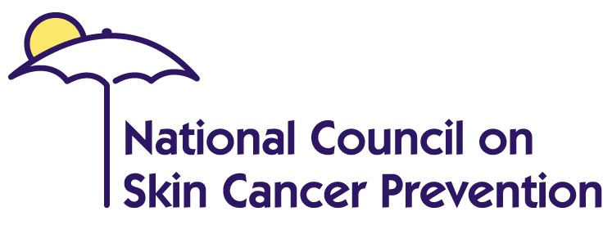
www.skincancerprevention.org


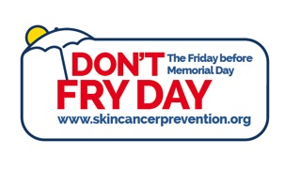
VIDEO TEXT – 30 Seconds
Don’t Fry Day

Did you know that one in five children will grow up to develop skin cancer? As we approach sun season, it is important to use our heads and protect them, along with the rest of our skin. In the same way we teach kids to wear bike helmets, we can also teach them to wear wide-brimmed hats. One catch way to remember sun safety is: Slip, Slop, Slap® and Wrap.

-Slip on a shirt;
-Slop on some sunscreen;
-Slap on a wide-brimmed hat; and
-Wrap on some sunglasses.

Listen for the UV Index, and have fun in the shade between the hours of 10 and 4.

This message was brought to you by the National Council on Skin Cancer Prevention’s Don’t Fry Day Campaign and the U.S. Environmental Protection Agency.

Find out more at: www.skincancerprevention.org

Statistics that can be displayed onscreen:
- More than two million Americans get skin cancer each year, outnumbering breast, prostate, lung, and colon cancers combined.
- One in five children will grow up to develop skin cancer.
- Melanoma is the most common form of cancer for young adults 25-29 years of age.

