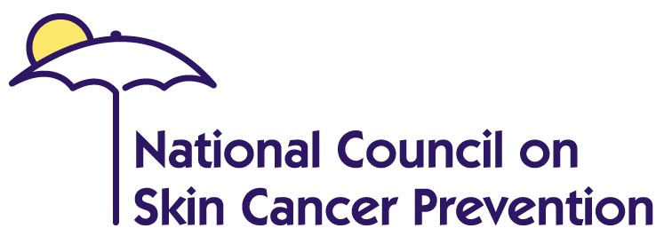
www.skincancerprevention.org


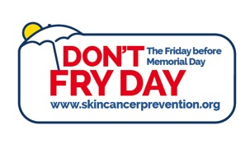
SKIN CANCER FACTS with STATISTICS
Don’t Fry Day

- Skin cancer is the most common form of cancer in the United States. More than 3.5 million new cases of skin cancers are diagnosed in more than 2.2 million people annually.
- It is estimated that one American dies every hour from skin cancer.
- Each year there are more new cases of skin cancer than the combined incidence of cancers of the breast, prostate, lung and colon.
- One in five Americans will develop skin cancer in the course of a lifetime.
- The sun is the primary source of excessive ultraviolet (UV) radiation, which is the cause of most skin cancers. Immediate adverse effects of excessive exposure are sunburn and eye damage; longer effects include premature aging of the skin and skin cancer.
- It is estimated that more than 3.5 million new cases of basal cell or squamous skin cancer (nonmelanoma) and 73,870 cases of melanoma (the most serious form of skin cancer) will be diagnosed in 2015 in the U.S.
- The incidence of many common cancers is falling, but the incidence of melanoma continues to rise significantly, at a rate faster than that of any of the seven most common cancers.
- The American Cancer Society estimates that 13,340 people will die from skin cancer in 2015, mostly due to malignant melanoma, which is among the fastest rising cancers in the U.S.
- Melanoma is the second most common form of cancer for young adults 15-29 years old.
- The number of women under age 40 diagnosed with basal cell carcinoma has more than doubled in the last 30 years; the squamous cell carcinoma rate for women has also increased significantly.
- In 2006, in the 116 largest (most populous) U.S. cities, there were, on average, more tanning salons than there were Starbucks® coffee shops.
- The states with the highest incidence rates of melanoma are: New Hampshire, Vermont, Rhode Island, Utah, Connecticut, Idaho, Delaware, Washington, Oregon, and Massachusetts.
- Whether from the sun or an artificial source, ultraviolet radiation (UVR) is a proven human carcinogen.

www.skincancerprevention.org

Fortunately, skin cancer also is one of the most preventable forms of cancer. To help prevent skin cancer:
- Wear protective clothing in the sun; wear a hat that shades the face, neck and ears; and plan outdoor activities around the midday sun.
- Examine the skin regularly. Suspicious lesions or progressive changes in a lesion’s appearance or size should be evaluated promptly by a physician.
- Wear sunglasses to protect eyes from UV light.
- Use a sunscreen with a broad spectrum sun protection factor (SPF) of 30 or higher and apply a generous amount (about a palmful) to all exposed skin 15-20 minutes before going outdoors. Reapply sunscreen every two hours throughout the day, especially after swimming, sweating, or towel drying. Use sunscreen even on hazy days.
- Avoid artificial sources of UV light (sunlamps, tanning beds).
- An easy way to remember these important sun safety tips is: Slip, Slop, Slap®… and Wrap — Slip on a shirt, Slop on broad spectrum sunscreen (SPF 30 or higher), Slap on a hat, and Wrap on some sunglasses.

American Cancer Society. Cancer Facts & Figures 2015 (2015): http://www.cancer.org/Research/CancerFactsFigures/CancerFactsFigures/cancer-facts-figures-2015
Ibid.
Ibid.
JK Robinson. “Sun Exposure, Sun Protection, and Vitamin D,” JAMA: The Journal of the American Medical Association (2005): 294, 1541-43.
U.S. Department of Health and Human Services, Centers for Disease Control and Prevention. Skin Cancer Questions and Answers: http://www.cdc.gov/cancer/skin/chooseyourcover/qanda.htm
American Cancer Society. Cancer Facts & Figures 2014 (2014): http://www.cancer.org/research/cancerfactsfigures/cancerfactsfigures/cancer-facts-figures-2014
U.S. Cancer Statistics Working Group. United States Cancer Statistics: 1999–2005 Incidence and Mortality Web-based Report. Atlanta: U.S. Department of Health and Human Services, Centers for Disease Control and Prevention and National Cancer Institute (2009): www.cdc.gov/uscs.
American Cancer Society. Cancer Facts & Figures 2014 (2014): http://www.cancer.org/Research/CancerFactsFigures/CancerFactsFigures/cancer-facts-figures-2014
U.S. National Institutes of Health, National Cancer Institute. “Cancer Epidemiology in Older Adolescents & Young Adults,” Surveillance Epidemiology and End Results AYA Monograph (2007): 53-63.
LJ Christenson, TA Borrowman, CM Vachon, MM Tollefson, CC Otley, AL Weaver, RK Roenigk. “Incidence of basal cell and squamous cell carcinomas in a population younger than 40 years,” JAMA (2005): 294: 681-690.
Katherine D. Hoerster, Rebecca L. Garrow, Joni A. Mayer, Elizabeth J. Clapp, John R. Weeks, Susan I. Woodruff, James F. Sallis, Donald J. Slymen, Minal R. Patel, Stephanie A. Sybert. “Density of Indoor Tanning Facilities in 116 Large U.S. Cities,” American Journal of Preventive Medicine, no. 36 (March 2009): 3, 243-246: http://www.ajpm-online.net/article/PIIS0749379708009756/abstract.
U.S. Department of Health and Human Services, Centers for Disease Control and Prevention and National Cancer Institute, U.S. Cancer Statistics Working Group. United States Cancer Statistics: 2001–2005 Incidence and Mortality Web-based Report (2010): www.cdc.gov/uscs.
U.S. Department of Health and Human Services, Public Health Service, National Toxicology Program. “Ultraviolet Radiation-Related Exposures,” Report on Carcinogens, Eleventh Edition (January 2005): http://ntp.niehs.nih.gov/ntp/roc/eleventh/profiles/s183uvrr.pdf.

