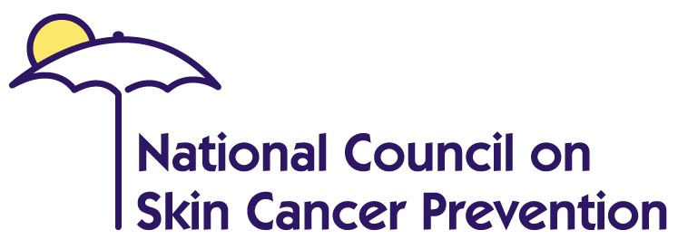
www.skincancerprevention.org


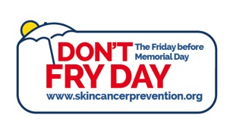
SUN SAFETY PACKING LIST
Don’t Fry Day

Vital Sun Safety-Related Items to Pack to Protect You and Your Loved Ones
- A wide-brimmed hat
- A broad-spectrum sunscreen with a Sun Protection Factor of 30 or higher (in your checked luggage if you are travelling via airline)
- Sunglasses
- Lip balm
- An umbrella
- Long-sleeved, light-weight shirts and pants
- A list of museums/other in-door sites to visit during the sun’s peak UV hours (between 10 and 4)
Helpful Hints:
Generously Apply Sunscreen
Generously apply sunscreen to all exposed skin using an SPF of at least 30 that provides broad-spectrum protection from both ultraviolet A (UVA) and ultraviolet B (UVB) rays. Reapply every two hours, even on cloudy days, and after swimming or sweating.
Wear Protective Clothing
On days when it is hotter outside than it is in your body, clothing insulates you from heat as it does from cold. Wearing light-colored, lightweight clothing, a wide brimmed hat, and sunglasses prevents heatstroke and sun damage in several ways:
- By reflecting sunlight away from the skin and eyes without absorbing so much of the heat.
- By keeping natural oils or lotions where they belong, on your body, rather than being evaporated into the air along with your sweat.
- By preventing these oils from being exposed to the heat and sunlight where they can fry.
Light-colored, lightweight clothing wicks some of the sweat away from the skin to keep you comfortable, but retains enough of it to help the sweat do its job of keeping you cool. In many other warm parts of the world, people dress modestly in summer for religious reasons and still manage to keep cool.
Use Extra Caution Near Water, Snow and Sand
Water, snow and sand reflect the damaging rays of the sun, which can increase your chance of sunburn.
Watch/Listen for the UV Index
The UV Index provides important information to help you plan your outdoor activities in ways that prevent overexposure to the sun.
Get Vitamin D Safely
Get vitamin D safely through a diet that includes vitamin supplements and foods fortified with vitamin D. Don’t seek the sun.
Seek Shade
Seek shade when appropriate remembering that the sun’s UV rays are strongest between 10 a.m. and 4 p.m. Remember the shadow rule when in the sun: Watch Your Shadow. No Shadow, Seek Shade!

